3950 NW 120th Ave, Coral Springs, FL 33065 TEL 561-955-9770 FAX 561-955-9760

Ferrari Portofino M.O.S.T. 150 to 12-channel Analog & Digital sound processor
NTV-KIT987

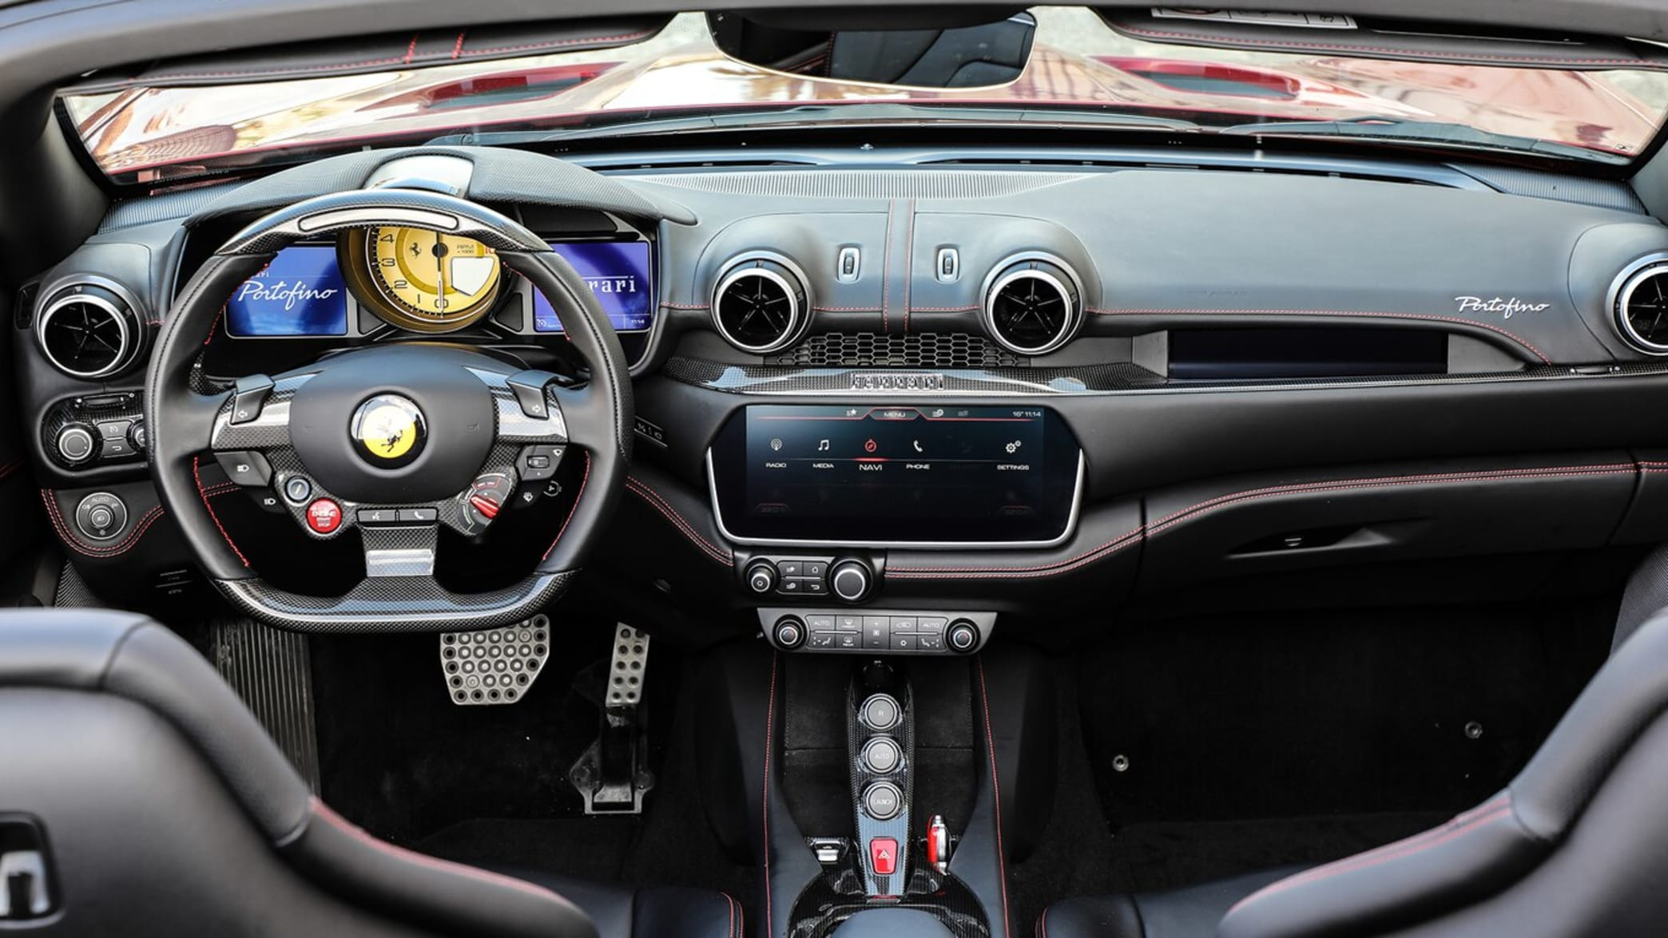

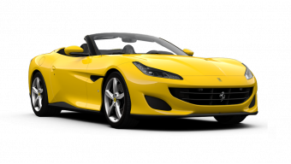

WARNING: Do not connect any RCA cables to the ZEN-F interface or additional processors prior to properly grounding aftermarket amplifier(s)!
Overview

The NAV-TV ZEN-F processor seamlessly converts Ferrari Portofino factory MOST-150 audio bus to 12-channel analog RCA and TOSLink output. Adding aftermarket amplifiers to the OE Ferrari system has never been so simple. This kit integrates with the OEM M.O.S.T.® bus to retain volume control, full fade (and balance: analog only), treble, mid-range & Bluetooth voice calls with no external speaker (true OEM integration). NOTE: OEM radio systems not equipped with a fiber optic amplifier are not compatible.
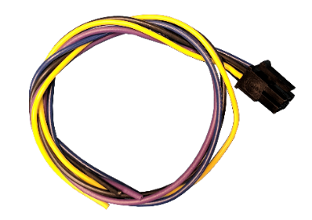
Kit Content
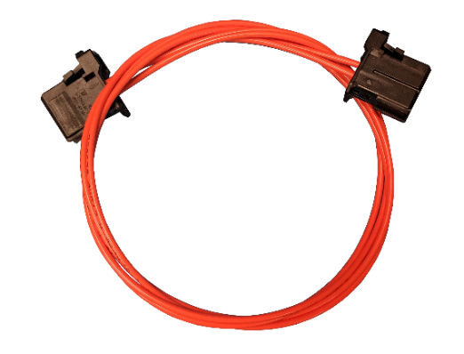
ZEN Power Harness
NTV-HAR316

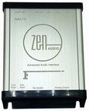
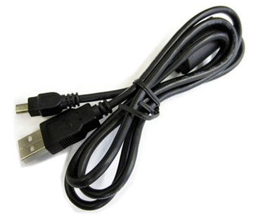
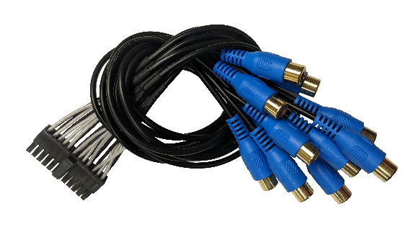

ZEN RCA Harness
NTV-HAR315
ZEN MOST Fiber
NTV-CAB134

USB Cable (updates)
NTV-CAB009

ZEN-F Interface
NTV-ASY319

ZEN-F overview
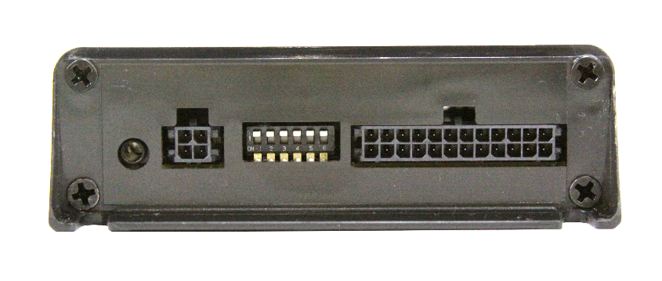
--FUTURE USE--
DIP switches
USB (updates)
TOSLink output
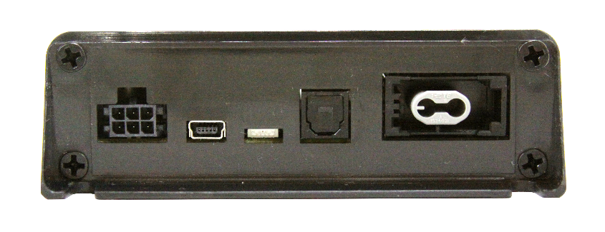

NTV-HAR247 Pin Side
Wire Side
Analog RCA outputs
--FUTURE USE--
Power
connector
MOST 150 fiber input
Status LED

Year(s) | Make | Model
2017+ | Ferrari | Portofino with MOST 150 fiber optic amplified audio system
ZEN-F Compatibility
Ferrari Portofino with MOST 150 fiber optic amplifier

ZEN-F Installation
- If this vehicle has a factory amplifier, it must be removed and the ZEN-F can be installed into its place. If this vehicle is not amplified from factory, it is not compatible with the ZEN-F.
See Below
ZEN-F pin | Color | To vehicle:
1 | Yellow | 12v (+) Constant
3 | Violet | --Reserved, NOT USED--
4 | Black | Ground (-)
6 | Blue | 12v (+) remote output*
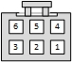
- Connect the following wires from the provided power harness:

Wire Side
*This remote wire must be used for aftermarket amplifier remote for proper functionality. If installing more than one amplifier/DSP, a relay must be used for reliable turn-on (500mA max).

- Before connecting power to the ZEN-F, adjust dip-switch settings for the desired options:
 | Time Alignment | Attenuation | TOSLink DownMix | Loudness | Vehicle Settings
Position | DIP 1 | DIP 2 | DIP 3 | DIP 4* | DIP 5 | DIP 6
UP  (off) | Front Row | Full Scale output (0 dB) | Not used | Keep in factory default  Loudness OFF
DOWN (on) | Driver Focused | -12 dB output | Not used | Loudness ON

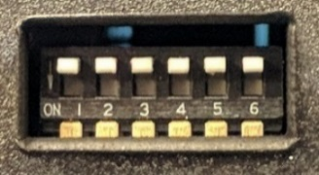

- If using analog RCAs for signal to the amplifier, connect according to the reference chart below. WARNING: Do not connect RCA cables to this interface until all amplifiers/external processors are properly grounded. Failure to do this may cause damage to the interface and VOID the warranty!
1 | 2 | 3 | 4 | 5 | 6 | 7 | 8 | 9 | 10 | 11 | 12
Left Front | Right Front | Left Front | Right Front | Left Front | Right Front | Left Rear Door | Right Rear Door | Left Rear Center | Right Rear Center | Center | Sub

- If using TOSLink for signal to the amplifier, connect the cable to the TOSLink port shown on page 2. NOTE: both Analog and Digital output sound simultaneously, regardless of which type is used.
- Connect the provided MOST Fiber Cable from the (previously removed) amplifier, or from the radio’s fiber port to the MOST port on the ZEN-F.
ZEN-F General Installation Notes

- This interface can only be installed in vehicles with a factory MOST fiber optic amplifier.
  - The factory amplifier must be removed. Connect the OEM fiber previously connected to the amp, directly into the ZEN-F.
- Tuning tips:
  - Before beginning tuning process (especially with external EQ/Processors), set Bass & Treble on the head unit for each source to flat (0).
  - Begin with amplifier/EQ gains all the way down.
  - With dynamic music playing, adjust the radio volume to maximum.
  - Adjust the amplifier/EQ gains to desired maximum level.
- From the factory, some vehicles’ audio will attenuate when in reverse. Simply set the ‘reverse volume’ to desired level while in reverse to adjust this. The ZEN-F will retain this method. The same is true for NAV guidance audio and BT voice calls.

Multi-Color LED Status Indication
LED Status | Indication
Solid Red | MOST Active
Violet | MOST traffic commands
Blinking Red | Peaking (maximum digital signal level achieved)
Blinking Blue | PC Link with app (future use)

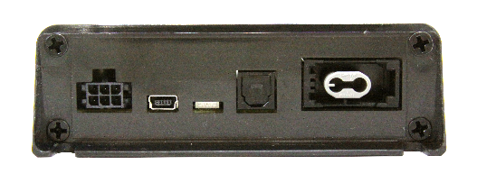

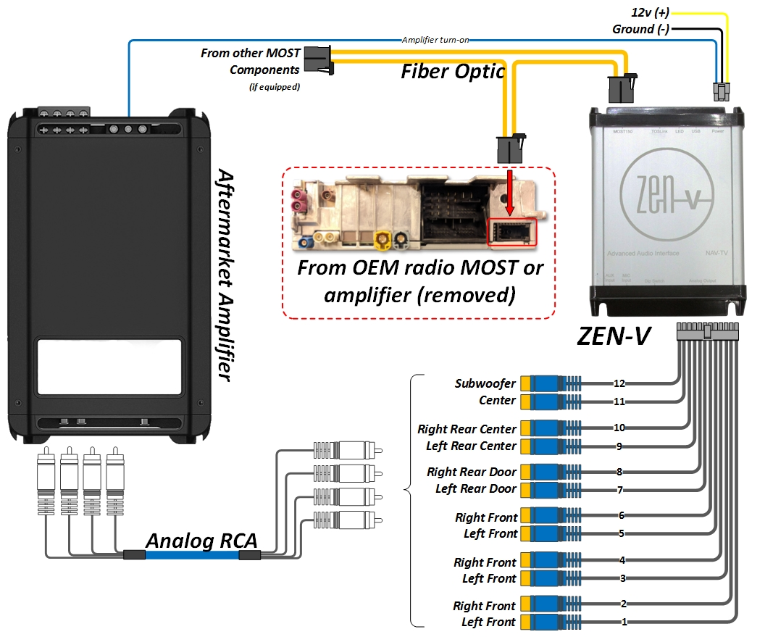
ZEN-F System Layout (analog)
For ZEN-F installations, the factory amplifier MUST be removed.

ZEN-F System Layout (digital TOSLink)
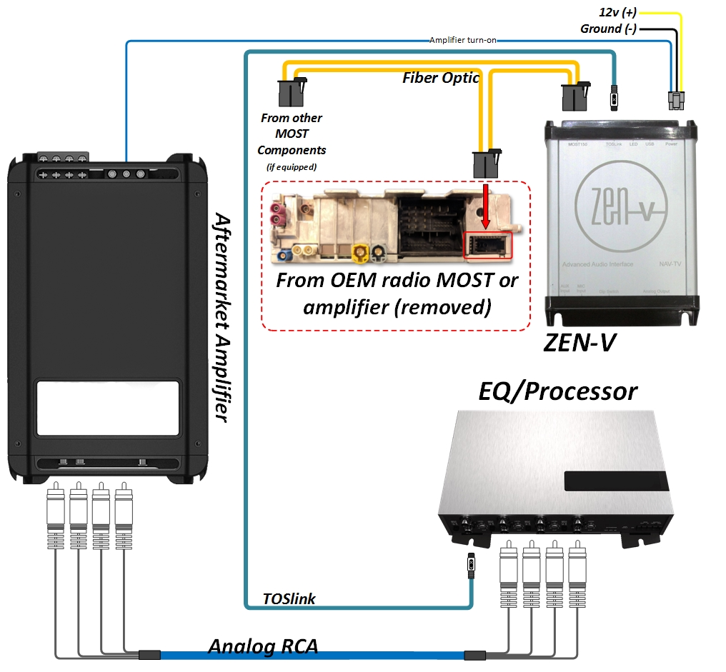

For ZEN-F installations, the factory amplifier MUST be removed.

ZEN-F Technical Specifications
Hardware & Software
Current HW version: | --1r0--
Current SW version: | ZEN-F-1.6.26-3-19-19
Compatible SW (update) OS: | Windows 7 (64 bit), 8, 10
INPUT
Digital Input | MOST 150 Fiber Optic
OUTPUT
Digital Outputs: | TOSLink
Digital Outputs supported: | 24bit/48kHz
Frequency Response (digital): | 18Hz – 24kHz
Analog Outputs: | 12 channels (RCA)
Output Voltage Peak: | 6v
Output Voltage RMS: | 2.1v
Analog Output Type: | Single-Ended
S/N Ratio (analog): | 114dB
Frequency Response (analog): | 18Hz – 24kHz
THD+N @ -1dBFS | -94dB
DAC | 48kHz 32bit
DSP | 32bit Floating Point
Delay (Time Alignment) | Selectable
Power Supply
Current Consumption Stand-by | <1 mA
Current Consumption Operational | 350 mA MAX
Operational Voltage | 7V – 20V DC
Amp Turn-On Output | Automatic
Amp Turn-On Voltage | V-batt
Amp Turn-On Current Limitation | 500mA
Other
Dimensions: | 4”x5”x1 3/8”
Weight: | 10 oz
Country of Origin: | USA

FAQ

- For installations with this ZEN processor, make certain that any added amplifier’s ground resistance (reference vehicle battery ground) does not exceed 1 ohm.
- If you’ve installed a third-party DSP (receiving signal from the ZEN, before the amplifier) and you’re having issues with audio bleeding from one channel to another, echoing Bluetooth phone calls or any other signal processing issues, rule out the ZEN first by temporarily bypassing the third-party DSP and running signal directly from the ZEN to the amplifier(s) and verify the problem still exists before calling technical support.

